NoRCEL’s Blue Earth Project
(An initiative of the Network of Researchers on the Chemical Evolution of Life)

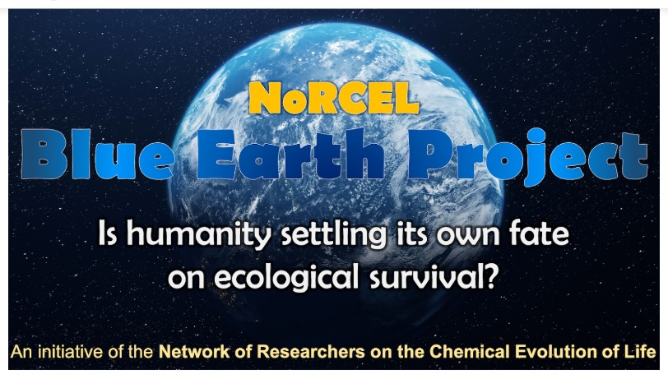

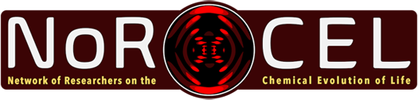

Blue Earth Project

Is humanity settling its own fate on ecological survival?

Introduction

Life is subject to continuous co-evolution with its environment. While planet Earth provides the conditions that permits life to exists, life itself alters these conditions. This process regularly involves the extinction of species. Does humanity sit on a branch of life that will continue to evolve, or on an unsuccessful branch of evolution? To what extent do we settle our own fate?
Humans cannot live directly from rocks, water, and sunlight, but depend on an elaborate and well-balanced biosystem, containing a diversity of fauna, flora, and plenty of microorganisms.
This balance is under threat. Not only do not need to be concerned about the disappearance of many of our fellow creatures from the face of Earth, but we also see an unprecedented growth of the human population. How much pressure on the ecosystem do we exert by raising population levels from 3 billion in 1960 to about 8 billion now and further rising, and can this be sustained by the finite resources of planet Earth and the processes that ultimately keep us alive? Where would this growth need to be stopped? What damage has already been caused and can that be mitigated?

At NoRCEL Blue Earth Project, we are therefore questioning: “What challenges does the rise in global human population pose for the future of humanity by changing the ecology and environment of our home planet Earth?”. To address this, we will host a one-day forum taking place on 8 January 2022, involving experts shining light on this issue from various perspectives.

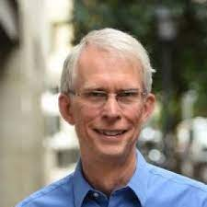

Prof Lowell Gustafson
Department of Political Science, Villanova University College of Liberal Arts and Sciences
lowell.gustafson@villanova.edu

Human Population Growth: A set of unprecedented questions

Abstract

Homo sapiens numbered in the thousands some 300,000 years ago. Two thousand years ago we numbered 190 million. In 1800, the number was just under a billion. A century later, it had risen to 1.65 billion. In the 121 years since, it has exploded to just under 8 billion, with expectations that it might rise to 11 billion by the end of our century. This is an unprecedented situation. Old practices and values may not help us solve the problems we face now. What is the range of issues we are facing now and in the next decades? What do policy makers across the globe need to be planning for? How should we be framing these issues and needs?

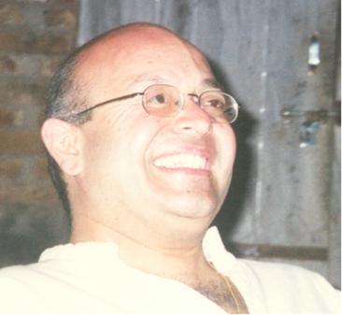

Dr Mukesh Chiman Bhatt
School of Law, Birkbeck College, University of London
m.bhatt@physics.org

A quest for life unchained and unbound

Abstract
Earth’s biosphere affects both the broader and specific Terran eco-systems. Life (and especially humanity) on Earth is meanwhile unbalancing its current “eternal” evolutionary homeostasis. It is science that presumes to define life and the essential parameters for its existence, continued or otherwise. Modern Western science has a history of human exceptionalism derived from theology. However, law and society are paramount in accepting what constitutes a living entity. And it is society and societal action that determines what constitutes a response to a change in state. However, Western society and its scientific paradigm is not the only basis for this response. Many cultures have different and broader definitions of what constitutes life. The ethical treatment of life within these cultures often includes attitudes towards non-human species and inanimate environments and eco-systems which are little understood or accepted in the West. Humanity is not seen as exceptional, but as part of nature. Its activities may be anthropogenic, but these activities are also seen as part of a set of general mechanisms that affect everything. Further, human law is the ultimate anthropogenic artefact: it arbitrates the definitions of life and its interactions in many cultures. Can any actions be taken that preserve an evolutionary path for humanity, or does it need to adjust its response to ensure that humanity is only one part of what survives and continues? And in this context, what is that we wish to preserve? Is it a particular vision of humanity within the current biosphere and eco-systems? Is it possible that the Terran biosphere is allostatic? The legal, cultural and other diversity present on Earth demands equally diverse approaches and attitudes in the definition of life. And in settling outer space or and travelling to eco-planets, are we justified in interfering with what may be future sites for the evolution and development of life? Perhaps life needs to defined and redefined, from the molecular or organic entity to various types of xeno-species and civilisations – whether post-Terran, post-human or non-Terran.

Prof Medina Omo Kadiri
University of Benin, Benin City, Nigeria
mokadiri@uniben.edu

Global assessment on biodiversity, conservation and environment

Abstract

It is no news that nature is deteriorating at a very fast pace globally. This is reflected in biodiversity, ecosystem services/functions and the general (biophysical) environment.
At present, about one million species (flora and fauna) are prone to extinction, more than at any other period of human history, coupled with imminent rapid acceleration extinction rate of global species. With the current trends of events, Agenda 2030, Vision 2050 and even Paris Agreement on Climate Change will be undermined. Biodiversity decline and environmental deterioration can/will greatly affect the United Nations’ Sustainable Development Goals (SDGs), particularly, SDG 1 (Poverty), SDG 2 (Hunger), SDG 3 (Health), SDG 6 (Water), SDG 11 (Cities), SDG 13 (Climate), SDG 14 (Oceans), SDG 15 (Land), and indirectly, even other SDGs.

Although population growth has been very slow in some millennia before now, due to climate fluctuation, diseases, etc, remarkable improvements in medicine, technology and nutrition have caused the colossal and exponential growth of world population. The estimation of United Nations indicates that the world population is expected to hit 9.2 billion by 2050. The implication of this, coupled with the current population, is increased waste generation, greenhouse gases emission, food production, utilization of resources, (water, forests, aquaculture, energy from fossil fuel, air, land and earth’s minerals), ultimately leading to an environmental catastrophe, due to unprecedented change in ecosystems, atmosphere and landscapes. Just like human population growth affects biodiversity, biodiversity loss also constitutes a serious threat to human existence and well-being. The relationship between human population and environment is multifaceted. A myriad of factors influences the environment and biodiversity and these include pollution, population, climate change, aquatic and land –use change, invasive alien species, and overexploitation.
A transformational change is required to curb the current trend of events (biodiversity loss & environmental deterioration), which may include technological, economic, social and political factors. Specifically, such changes encompass environmental education, behavioural and nature-based change (consumption pattern), energy increases, (alternative energy exploitation), technological innovation (agriculture, water security (water purification) and genetic engineering etc), policy, governance, climate change mitigation and nature conservation. There should be sustainability in agriculture, aquaculture, animal husbandry, freshwater management, protection of native species, varieties, breeds and habitats, coupled with ecosystem restoration. These will help in the conservation of nature without depriving humans of their daily requirements or needs.

To safeguard the global environment, local efforts and international cooperation are required. The onus is on all (government, communities, individuals etc) to protect the environment and biodiversity, while working towards a sustainable future, through a synergy between environment and development.

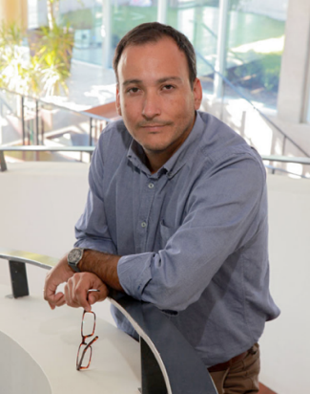

Dr Alex Godoy-Faúndez
Global Young Academy and CiSGER, Facultad de Ingeniería, Universidad del Desarrollo
alexgodoy@ingenieros.udd.cl

Economic system and growth, engineering, and ecosystems? How the planet has subsidized the well-being.

Abstract

Today, our civilization is living in a big paradox. We have achieved the highest of wealth levels with the worst ecosystems’s detrimental by continual extraction of natural resources and exposure to climate change impacts as well as being a sink of wastes, discharges, and emissions. All those impacts are linked to unsustainable production surpassing planetary boundaries driving climate and ecological catastrophe forehand. The production and consumption are structured by an unsustainable economic model encouraging continuous growth beyond planetary limits without internalizing socio-environmental costs. Then, the modern economy and the goods and products prices traded into the markets through time have been based on production costs without internalizing social (inequity) and environmental externalities (depletion). The prices of goods and services hide those external costs because it’s generally cheaper for a product with a worse impact than the equivalent product that does less harm. Therefore, the higher costs to the planet do not translate to higher prices into markets, been those goods and services subsidized by nature by hiding socio-environmental harm. Today, carbon prices have been proposed to internalize the climate change impact but leaving behind the environmental damage and social inequity issues. This presentation will discuss the subsidy by nature and the false pricing of goods and services traded by current economies.

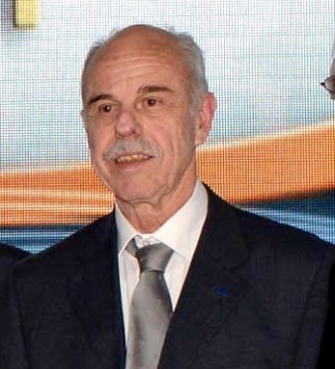

Prof Nathan Nelson, Emeritus in Biochemistry Molecular Biology
The George S. Wise Faculty of Life Sciences, the Tel Aviv University, Israel
nelson@tauex.tau.ac.il

Energy management for sustainability

Abstract

The 2nd law of thermodynamics governs life on earth and defines the fate of human race. Life is an expression of increased order, thus consequently causes much greater disorder in its surroundings. Therefore, the world population must be limited into a manageable number. I would estimate that 5 billion people is the upper limit of sustainable population on earth, providing there will be a zero growth in lifestyle. We must go back to July 11th in 1987 in terms of world population, energy demand, number of cars, milage of flights and tangible productivity. The dream of destroying our planet and go somewhere else is not realistic. With high degree of certainty, I would predict that we have no match in our galaxy and if there is one, there is a very slim chance, we will ever encounter it. Thus, we must start acting now to limit the global energy consumption. We must take into account not only population growth but also global amount of money as an enabler of energy consumption. Accordingly, the 10 trillion dollars printed by governments and stock markets in the last two years, is as damaging to the environment as oil usage. The following steps should be implemented:

- Gradually but decisively reduce the world population to 5 billion people by encouraging 1.5 children per family;
- Gradually decrease the lifestyle to the level of 1987 by advocating limits of excessiveness;
- Heavy taxation on the use of energy in any shape or form; and
- Obeying the thermodynamic rules in energy production, consumption, storage and waste disposal.

